CHAPTER THREE
MATERIALS AND METHODS
This chapter presents the materials and methods adopted in fine-tuning a Large Language Model (LLM) agent for a fitness chatbot system using a Mistral-based model, in line with the aim and objectives stated in Chapter One. It begins by analysing existing fitness chatbot systems and their limitations, proceeds to justify and design the proposed system, and concludes with the methodology, flowchart, use-case structure, database design, and layered architecture that will be implemented.

3.1 Analysis of Existing System
Several fitness-related conversational and tracking systems already exist in the commercial and research space.
System | Core Approach | Key Limitation Relative to Proposed System
ChatGPT (general-purpose) | General LLM, no fitness fine-tuning, no persistent user profile | Not domain-specialized; no guardrails specific to exercise/nutrition safety; no goal tracking
Google Fit | Sensor-based activity tracking with rule-based prompts | No conversational reasoning; cannot answer open-ended fitness questions
MyFitnessPal | Calorie/macro logging with limited chat features | Chatbot layer is shallow; no LLM-level natural language understanding
Fitbit Coach | Guided workout videos with scripted instructions | Static content; no personalized natural-language dialogue or memory
Lark AI | AI health coach for chronic-disease and lifestyle coaching | Broad wellness focus dilutes fitness-specific depth; limited RAG/knowledge grounding
Freeletics | Rule-based workout plan generator | No true conversational agent; adaptation is template-based, not model-based
IBM Watson Fitness Chatbot (Lola et al., 2021) | Enterprise dialogue platform for scheduling and Q&A | Intent-slot architecture rather than a fine-tuned generative LLM; limited personalization depth

Beyond the specific systems above, the broader empirical literature reviewed in Chapter Two — including Fadhil and Al-Jumeily's (2019) rule-based fitness and nutrition chatbot, Miura et al.'s (2022) rule-based system for older adults, and Mateos-Sánchez et al.'s (2022) rule-based system for users with disabilities — shares a common architectural pattern: predefined rules or narrow intent classifiers rather than a generatively fine-tuned Large Language Model. This pattern is why, across the board, these systems struggle with unscripted phrasing, cannot sustain multi-turn context, and provide no explicit safety layer for exercise or nutrition advice.

3.1.1 Underlying Algorithm of Existing General-Purpose Systems
Where the reviewed system is a general-purpose Large Language Model (LLM) rather than a rule-based tool — for example, the unmodified ChatGPT baseline in Section 3.1 — its underlying algorithm is established and consistent across the field, and is stated here because it is the baseline the proposed system in Section 3.3 is measured against.
Architecture: The Transformer (Vaswani et al., 2017), which uses self-attention to weigh the relationship between every word in a sequence simultaneously, rather than processing text one word at a time as older Recurrent Neural Networks (RNNs) do.
Base Training Algorithm: Self-supervised pretraining through next-token prediction (causal, autoregressive language modelling) — the model is trained on massive unlabelled text corpora by repeatedly predicting the next word, requiring no human-labelled examples.
Optimization Algorithm: Gradient descent via the AdamW optimizer, which adapts the learning rate per parameter and stabilizes training at billion-parameter scale.
Mistral-Specific Additions: Grouped-Query Attention (GQA) for faster inference and Sliding Window Attention (SWA) for handling longer text sequences at lower computational cost, both layered on top of the standard Transformer architecture as already established in Chapter One.
This combination produces broad, general-purpose language ability with no fitness-domain specialization and no safety layer — the exact gap that Sections 3.3 and 3.5.1 close through Quantized Low-Rank Adaptation (QLoRA) fine-tuning, Retrieval-Augmented Generation (RAG), and the guardrail layer.

3.2 Advantages of Existing System
The existing systems reviewed above already deliver measurable value: automated logging, scripted coaching prompts, and, in the case of general-purpose systems like ChatGPT, fluent conversation. Their principal strengths include:
- Low latency and reliability, since rule-based logic is deterministic and does not depend on probabilistic generation.
- Simple, well-understood maintenance for narrowly scoped tasks such as calorie logging or step counting.
- Wide existing user bases and device-sensor integration (for example, Google Fit and Fitbit's accelerometer and heart-rate data).
- General-purpose fluency of large pre-trained conversational models such as ChatGPT, which handle varied phrasing well even without fitness-specific tuning.
The research gap that remains, despite these strengths, is the absence of a single system that combines fitness-domain fine-tuning, retrieval-grounded factual accuracy, persistent personalization, and an explicit guardrail layer that prevents unsafe medical or exercise advice. This gap is precisely what Section 3.3 addresses.

3.3 Analysis of the Proposed System
The proposed system reframes the fitness chatbot not as a single monolithic program but as a coordinated set of components, each contributing a distinct capability to an overall Artificial Intelligence (AI) agent.
User (Web Application) The entry point through which an individual interacts with the chatbot, built as a single React web application accessible from any modern browser on desktop or mobile. A browser-based React front end was chosen over a native mobile build because it lets one codebase reach every device without a separate mobile release cycle, which matches this project's cloud-only, resource-constrained development environment.
Authentication Service — The layer that verifies a user's identity before granting access to personalized data, implemented through Supabase Authentication. Fitness and health data are sensitive; without authentication, the personalization and guardrail layers described later would have no reliable identity to attach recommendations or safety checks to.
Backend Server (FastAPI) — A Python FastAPI service that acts as the explicit orchestration layer between the React frontend, Supabase, the vector database, and the fine-tuned model's inference endpoint. FastAPI was selected for this role because it gives the project a single, well-defined coordination point — every request from the React client is routed through it to authentication, retrieval, prompt construction, and the model — which keeps the frontend, the data stores, and the AI layer decoupled and independently upgradable, for instance, swapping the Mistral-based model for another Large Language Model (LLM) Application Programming Interface (API), as the project's flexibility clause permits.
Fitness Knowledge Base — A curated repository of verified exercise, nutrition, and recovery documents distinct from the model's fine-tuning dataset. Fine-tuning bakes knowledge into the model's weights at a fixed point in time; a separately updatable knowledge base is what allows the chatbot to stay current with new guidelines without repeating the entire fine-tuning process.
Embedding Model — A smaller neural network that converts text (documents and user queries) into fixed-length numeric vectors that capture semantic meaning. Semantic search is only possible once text is represented numerically; this component is the bridge between raw fitness documents and the searchable index described next.
Vector Database — A specialized database (Pinecone or ChromaDB) optimized for storing and searching those numeric vectors by similarity rather than by exact keyword match. Fitness questions are rarely phrased identically to reference material; similarity search is what lets the system find the most relevant passage even when the user's wording differs from the source document.
Retrieval-Augmented Generation (RAG) Pipeline — The process of retrieving the most relevant knowledge-base passages for a given query and inserting them into the prompt before generation. This is the single most direct defence against hallucination — instead of relying purely on what the fine-tuned model memorized, the model is handed verified source text at answer time, which is essential when the topic is health-adjacent.
Large Language Model (Fine-Tuned Mistral-Based Model) — The generative core of the system, adapted from a general-purpose 7-billion-parameter Mistral model to the fitness domain through Quantized Low-Rank Adaptation (QLoRA) fine-tuning on a fitness Question-and-Answer (Q&A) dataset, using the Hugging Face Transformers and Parameter-Efficient Fine-Tuning (PEFT) libraries. Fine-tuning, rather than using the base model unmodified, is what allows the agent to consistently speak in a fitness-coaching register, recognize domain terminology, and produce structured advice instead of generic text; QLoRA specifically makes this feasible on free-tier cloud hardware by quantizing the base model to 4-bit precision and training only small low-rank adapter weights instead of the full parameter set.
Prompt Engineering Layer — The component that assembles the final instruction sent to the Large Language Model (LLM) by combining the user's question, retrieved knowledge, the user's stored profile, and a summary of prior conversation. The fine-tuned model can only reason over what it is shown in a single forward pass; this layer is what injects personalization and retrieved facts into that pass without requiring further training.
Guardrail Layer — A rule-based and classifier-based safety filter that inspects both the user's input and the model's draft output before anything reaches the user. This is the explicit answer to the project's stated intent to 'guard it, not just train it' — fine-tuning alone cannot guarantee the model will never suggest a contraindicated exercise or attempt a medical diagnosis, so a separate, auditable safety layer is required.
Response Generation Engine — The component that finalizes the guardrail-approved output into a user-facing message, sometimes reformatting it (for example, into a numbered workout list). Presentation quality affects whether users act on advice; this stage decouples the model's raw generation from what is actually displayed.
Conversation Memory — A mechanism that persists a compressed record of the dialogue across sessions rather than only within a single exchange. Fitness coaching is inherently longitudinal — a goal stated last week must still shape this week's advice, which a stateless Question-and-Answer chatbot cannot achieve.
User Progress Tracking — The module that logs measurable outcomes (weight, workout completion, endurance test results) over time. Motivation, one of the project's core objectives, depends on users being able to see quantifiable evidence of change, not just receive encouragement in text.
Analytics and Admin Dashboard — A separate React-based web interface for administrators to monitor usage, review flagged guardrail events, and manage knowledge-base content. Fine-tuned models and knowledge bases require ongoing human oversight; this component is where that oversight is operationally exercised.
Data flows through these components in a single, traceable path: a request originates at the React web application, passes through authentication and the FastAPI backend, is enriched by the retrieval pipeline and prompt engineering layer, is generated by the fine-tuned Large Language Model (LLM) served through the Hugging Face Inference API, is checked by the guardrail layer, and is finally logged into conversation memory and progress tracking before the response reaches the user. This traceability is itself a design requirement — an examiner evaluating the system's safety claims must be able to see exactly where a response could be intercepted and corrected.
3.3.1 Algorithm of the Proposed System
Where Section 3.1.1 stated the single algorithm underlying an unmodified general-purpose Large Language Model (LLM), the proposed system has no single equivalent — it is a five-stage algorithmic pipeline, each stage handling a distinct part of turning a raw user query into a safe, fitness-grounded response. The five stages are presented below in the order they execute at runtime, consistent with the flowchart in Section 3.5.2.
1. Embedding Algorithm — A pre-trained sentence-embedding transformer (for example, all-MiniLM) converts both the user's query and the knowledge-base documents into fixed-length numeric vectors in the same vector space, making semantic comparison possible in the first place.
2. Retrieval Algorithm — Semantic similarity search (cosine similarity nearest-neighbor search) over those vectors in the vector database, returning the knowledge-base passages closest in meaning to the query, regardless of exact wording.
3. Fine-Tuning Algorithm — Quantized Low-Rank Adaptation (QLoRA), detailed fully in Section 3.5.1's stage (8). This is the technical centre of the research and the project's specific contribution — the other four stages integrate established techniques, while this stage is where the base Mistral model is actually specialized for fitness.
4. Generation Algorithm — Autoregressive next-token generation by the QLoRA-fine-tuned Mistral 7B model — the same core generation mechanism described in Section 3.1.1 for the baseline model, now operating on weights adapted to the fitness domain.
5. Guardrail Algorithm — Rule-based pattern matching (banned topics, medical-diagnosis phrasing) combined with a lightweight classifier for paraphrased or previously unseen unsafe content, detailed fully in Section 3.5.1's stage (9).

3.4 Advantages of the Proposed System
Personalization: Responses are generated using the user's stored profile, goals, and history rather than a one-size-fits-all script. A workout suitable for a 22-year-old beginner is not suitable for a 55-year-old with a knee injury; personalization is what makes the advice usable rather than merely correct in the abstract.
Safety (Guardrails): An explicit filtering stage sits between generation and delivery. This is the direct technical answer to the limitation identified in Chapter One — that most existing fitness chatbots provide advice that is not verified or safe by construction.
Accuracy through Retrieval: The Retrieval-Augmented Generation (RAG) pipeline grounds answers in verified documents. It reduces reliance on the fine-tuned model's frozen internal knowledge, directly addressing the risk of outdated or hallucinated fitness claims.
Domain Specialization: Fine-tuning on a fitness Question-and-Answer (Q&A) dataset shifts the model's default behaviour toward fitness-relevant vocabulary and reasoning. A general-purpose model like unmodified ChatGPT must be prompted carefully every time to stay on-topic; specialization makes correct behaviour the default, not the exception.
Context Awareness: The prompt engineering layer carries forward pronouns, prior goals, and running themes across a conversation. Fitness coaching conversations are naturally multi-turn ('increase that last week' implies memory of what 'that' refers to); without this, every message would need to be self-contained, which is unnatural for users.
Long-Term Memory: A compressed conversation memory persists across sessions, not just within one chat. Fitness goals unfold over weeks and months; a system that forgets everything between logins cannot meaningfully track progress.
Scalability: The layered, service-based architecture allows each component (retrieval, model, database) to be scaled independently on cloud infrastructure. As the user base grows, computational bottlenecks (for example, in the Large Language Model layer) can be addressed without redesigning the whole system.
Maintainability: Components communicate through defined interfaces rather than being tightly coupled. The knowledge base, the guardrail rules, and even the underlying Large Language Model (LLM) can each be updated independently, which is consistent with the project's own flexibility clause on substituting the base model.
Security: Authentication, access control, and encrypted storage protect sensitive health-related data. Fitness profiles often include medical flags; a breach would have real consequences for users, so security cannot be an afterthought.
Response Quality: Combining retrieval, personalization, and fine-tuning produces answers that are both fluent and factually anchored. Fluency without accuracy is misleading, and accuracy without fluency is unusable; the architecture targets both simultaneously.
Modern Artificial Intelligence Architecture: The system follows a Retrieval-Augmented Generation and agentic design pattern rather than the intent-slot pattern used by most systems in Section 3.1. This is the architectural basis for calling the chatbot an agent rather than a simple Question-and-Answer tool — it reasons over retrieved context and stored state rather than matching fixed intents.
Low Hallucination Risk: Grounding generation in retrieved, verified documents and validating output through guardrails together reduce the chance of fabricated claims reaching the user. In a health-adjacent domain, a fabricated claim is not a minor inconvenience — it can lead to injury or harm, making hallucination mitigation a core, not peripheral, design goal.

3.5 Design of the Proposed System
The overall design is organised into distinct layers, structured in Table 3.2 below, followed by the reasoning for why that particular layering was chosen over a monolithic design.
Layer | Core Components | Technology | Responsibility
Presentation Layer | End-user chat interface; administrator dashboard route | React (JavaScript) | Renders the interface; captures user input and displays responses
Application Layer | Backend orchestration server | Python, FastAPI | Single coordination point routing every request to authentication, retrieval, prompt construction, and the model
Artificial Intelligence (AI) Layer | Fine-tuned Mistral-based LLM; prompt engineering module; guardrail filter | Hugging Face Inference API, QLoRA-fine-tuned Mistral 7B | Generates draft responses and validates them before release
Data Layer | Relational store (users, goals, progress); vector store (semantic search) | Supabase PostgreSQL; Pinecone or ChromaDB | Persists structured user data and enables similarity-based knowledge retrieval
Knowledge Layer | Curated fitness knowledge base and its embeddings | Embedding model + vector database | Keeps verified fitness knowledge updatable independently of the model's fine-tuning data
Security Layer | Authentication tokens; role-based access control; encryption | Supabase Authentication | Protects sensitive health-adjacent user data at rest and in transit
Administration Layer | Knowledge curation tools; guardrail-flag review; analytics | React (JavaScript) admin dashboard | Gives administrators the oversight surface needed to maintain the system post-deployment
Table 3.2: Layered design of the proposed system — components, technology, and responsibility per layer.
Isolating each layer behind a defined interface is what allows any one of them to change without the others being touched — for instance, the Artificial Intelligence (AI) Layer's model can be swapped for another Large Language Model (LLM) Application Programming Interface (API), as the project's flexibility clause permits, without altering the Data Layer, the Security Layer, or the React frontend. This decoupling is the practical mechanism behind the scalability and maintainability claims made in Section 3.4.

3.5.1 Methodology of the Proposed System
The methodology is presented as a sequential pipeline. Each stage states what happens and what output it produces, so that the pipeline as a whole can be reproduced and defended.
(1) Requirement Analysis — Gathering the functional needs identified in Chapter One (personalization, 24/7 access, goal tracking, safety). Expected output: a documented requirements specification.
(2) Dataset Collection — Assembling fitness-domain text from verified sources and generating question-and-answer pairs. Expected output: a raw fitness Question-and-Answer (Q&A) corpus.
(3) Dataset Cleaning — Removing duplicate, contradictory, or unverified entries and normalizing formatting. Expected output: a cleaned, de-duplicated training dataset.
(4) Knowledge Base Preparation — Organising the retained fitness documents that will support the Retrieval-Augmented Generation (RAG) layer, distinct from the fine-tuning set. Expected output: a structured, source-attributed knowledge repository.
(5) Embedding Generation — Passing each knowledge document through the embedding model to produce vector representations. Expected output: a set of document embeddings ready for indexing.
(6) Vector Database Indexing — Loading the embeddings into Pinecone or ChromaDB with similarity search configured. Expected output: a queryable vector index.
(7) Prompt Engineering — Designing templates that combine retrieved passages, user profile data, and conversation memory into a single instruction for the model. Expected output: a tested set of prompt templates.
(8) Fine-Tuning (QLoRA) — Adapting the pre-trained Mistral-based model's weights on the cleaned fitness Question-and-Answer (Q&A) dataset using Quantized Low-Rank Adaptation (QLoRA): the base model is loaded in 4-bit NormalFloat (NF4) precision via the Hugging Face Transformers and bitsandbytes libraries, and small trainable low-rank adapter matrices are inserted and trained using the Parameter-Efficient Fine-Tuning (PEFT) library together with the Transformer Reinforcement Learning (TRL) SFTTrainer. This parameter-efficient approach is what makes fine-tuning a 7-billion-parameter model achievable on the free-tier cloud hardware described in Section 3.5.1.1, rather than requiring dedicated GPU infrastructure. Expected output: a fitness-specialized model checkpoint (adapter weights) pushed to the Hugging Face Hub.
(9) Guardrail Implementation — Building rule-based checks (banned topics, medical-diagnosis phrasing detection) and a lightweight classifier to flag unsafe draft responses. Expected output: a guardrail module with a documented set of blocking rules.
(10) Model Integration — Connecting the fine-tuned model to the FastAPI backend's inference calls through the Hugging Face Inference API (or an alternative Large Language Model Application Programming Interface, per the project's flexibility clause). Expected output: a working inference Application Programming Interface (API) endpoint.
(11) Backend Development — Implementing authentication, business logic, and orchestration between the database, retrieval pipeline, and model within the FastAPI service. Expected output: a deployed backend service.
(12) Frontend Development — Building the React web application and its administrator dashboard route. Expected output: a functional web application and dashboard.
(13) Testing — Verifying functional correctness (does retrieval return relevant documents, does the guardrail block unsafe content) and usability. Expected output: a test report covering functional and safety cases.
(14) Evaluation — Measuring accuracy, precision, recall, and user-perceived response quality. Expected output: evaluation metrics and results.
(15) Deployment — Releasing the system to a controlled user group or production environment. Expected output: a live, accessible fitness chatbot system.
(16) Continuous Learning — Establishing a feedback loop where flagged responses and user ratings inform future dataset updates and re-fine-tuning cycles. Expected output: a recurring update and retraining schedule.
The fine-tuning stage above is the technical centre of this research, so it is expanded visually below. Figure 3.5 traces how the general-purpose Mistral 7B base model is narrowed into a fitness-specialised checkpoint through the QLoRA process, and where a re-tuning loop re-enters the pipeline if evaluation results fall short of the thresholds set in Section 3.1.3.
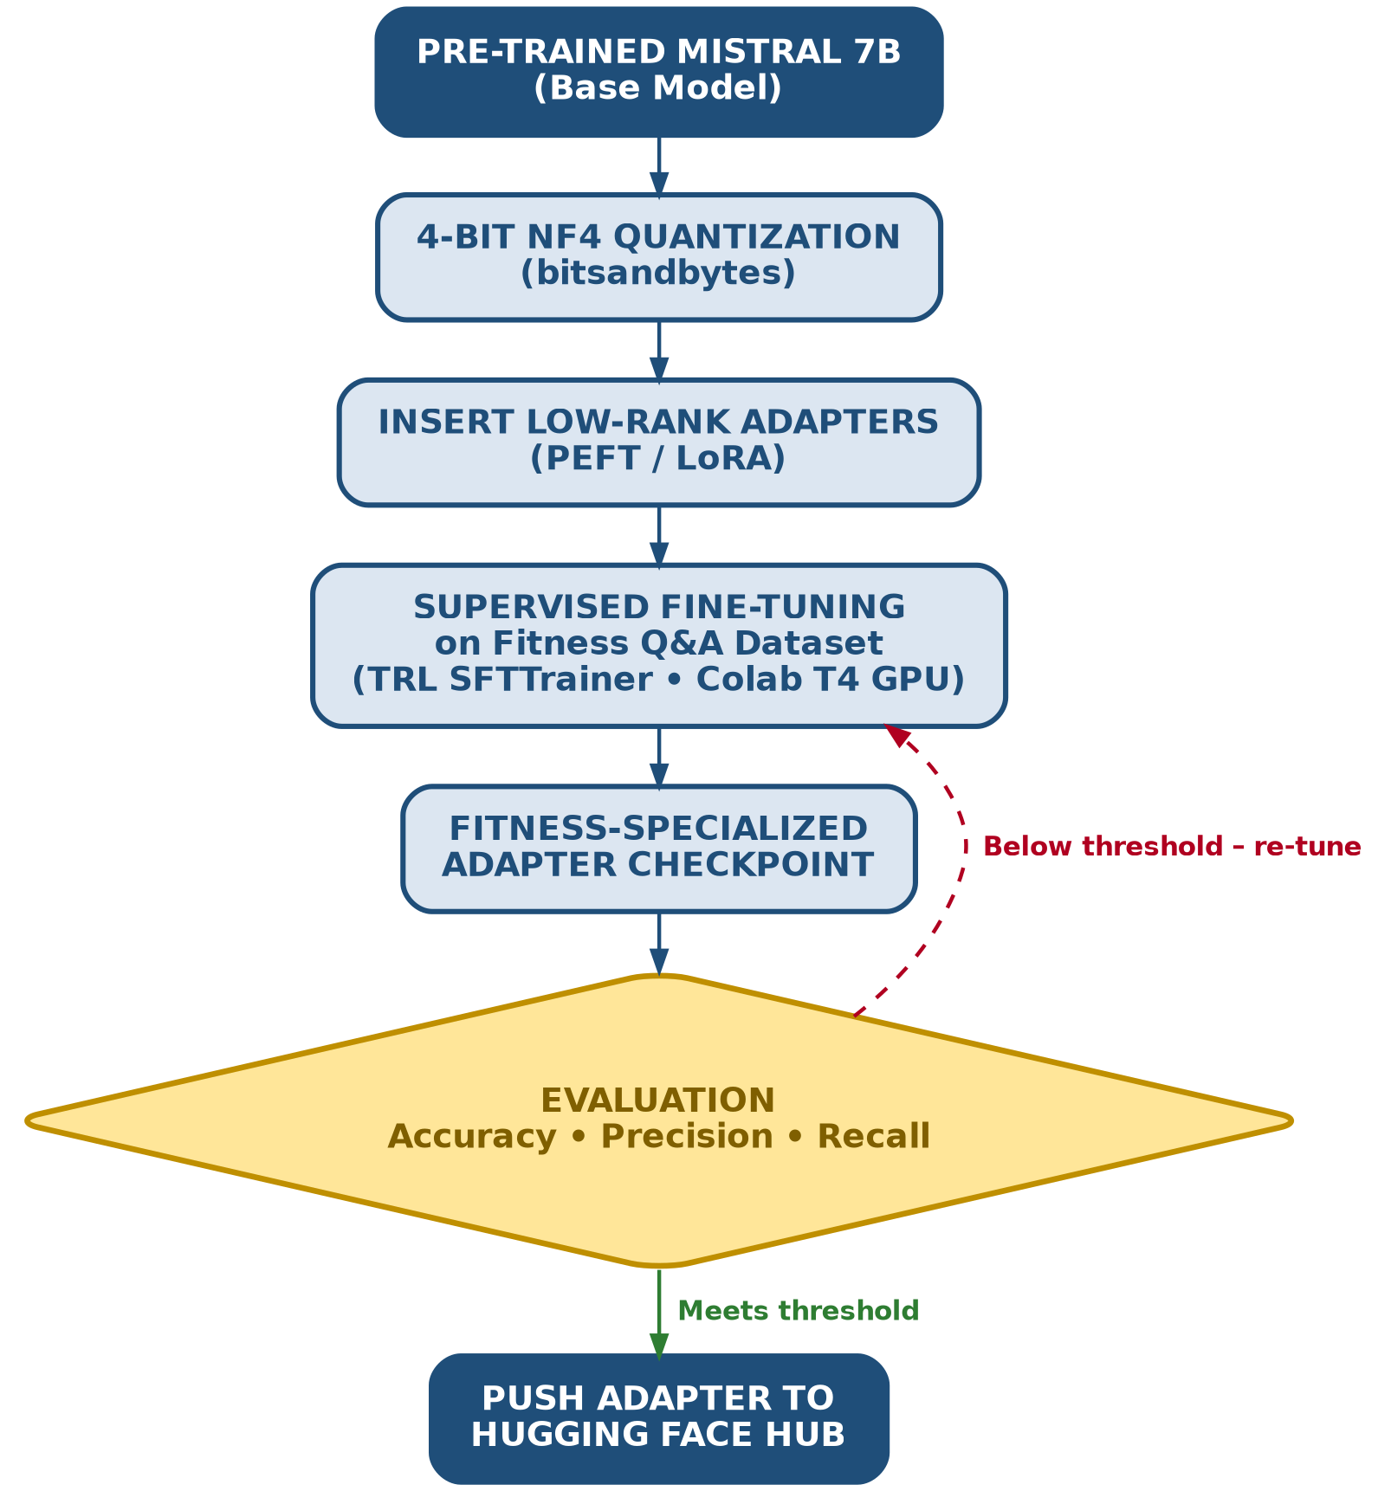
Figure 3.5: QLoRA fine-tuning pipeline showing how the base Mistral-based model is specialised into a fitness-domain checkpoint, including the re-tuning loop triggered by weak evaluation results.

3.5.1.1 Hardware and Software Requirements
This subsection states the actual compute environment the pipeline in Section 3.5.1 runs on, methodology must be reproducible by an examiner or future researcher on the same terms it was built.
Training Hardware: Google Colaboratory (Colab) free tier, providing time-limited access to a single NVIDIA T4 Graphics Processing Unit (GPU) with 16 gigabytes of Video Random Access Memory (VRAM). No dedicated or owned GPU infrastructure is used at any stage of this project.
Why QLoRA specifically fits this constraint: A T4's 16 gigabytes of VRAM cannot hold a full-precision 7-billion-parameter model plus optimizer states for full fine-tuning. QLoRA's 4-bit quantization of the base model, combined with training only a small set of low-rank adapter parameters, reduces memory demand enough to fit within this free-tier ceiling, which is precisely why QLoRA — rather than full fine-tuning — is the method this project can practically execute.
Artifact Storage: Trained adapter checkpoints are pushed to the Hugging Face Hub at no cost, rather than stored on local or paid cloud storage, keeping the entire training-to-hosting pipeline within free-tier services.
Inference Hosting: The Hugging Face Inference API serves the fine-tuned model for live requests from the FastAPI backend, removing the need to provision or pay for a dedicated inference server.
Core Software Libraries: Hugging Face Transformers (model loading and tokenization), PEFT (Parameter-Efficient Fine-Tuning — LoRA/QLoRA adapter management), TRL (Transformer Reinforcement Learning — the SFTTrainer used for supervised fine-tuning), and bitsandbytes (4-bit quantization).
Development Environment: Jupyter-notebook-based development within Google Colab for the training pipeline; standard code editors for the FastAPI backend and React frontend.
Because every stage of training and hosting runs on free-tier cloud services rather than owned hardware, this project's reproducibility and cost profile are directly tied to the availability of these free tiers — a limitation carried forward into Chapter Five.

3.5.1.2 Data Sources for the Fine-Tuning Dataset
The fitness Question-and-Answer (Q&A) dataset used in Section 3.5.1's Dataset Collection stage is drawn from verifiable sources rather than unattributed text, since a health-adjacent chatbot's factual reliability is only as strong as the material it was trained on.
- World Health Organization (WHO) physical activity and nutrition guidelines.
- Publicly available guidance from recognized fitness and exercise-science bodies, including the American College of Sports Medicine (ACSM) and the American Council on Exercise (ACE).
- Peer-reviewed exercise-science and sports-medicine literature, drawn from the same body of empirical work already surveyed in Chapter Two.
- Reputable public health and fitness reference content, such as the National Health Service (NHS) and Mayo Clinic fitness resources.
- Synthetically generated Question-and-Answer (Q&A) pairs drafted from the sources above and manually reviewed for accuracy before inclusion in the training set.
Sourcing the dataset this way — verified documents first, synthetic Q&A generation second, manual review third — is what the Dataset Cleaning stage in Section 3.5.1 depends on; a dataset assembled from unverified text would carry that risk directly into the fine-tuned model's behaviour.

3.5.1.3 Programming Languages
Three languages are used across the system, each scoped to a specific phase of the pipeline described in Section 3.5.1.
Python — Used for the FastAPI backend, request orchestration, and the entire QLoRA fine-tuning pipeline (Hugging Face Transformers, PEFT, TRL, bitsandbytes). Python is the language every core AI/ML library in this project's stack is written for, so the backend and training code share the same language rather than requiring a translation layer between them.
JavaScript — Used for the React frontend, covering both the end-user web application and the administrator dashboard. React is a JavaScript library; no TypeScript is used in this project, keeping the frontend toolchain lightweight and consistent with the project's cloud-only, resource-constrained development approach.
SQL — Used for querying and managing structured data in Supabase PostgreSQL — user profiles, goals, workout plans, and progress records. SQL is used directly rather than through a heavy Object-Relational Mapping (ORM) layer, keeping the relational queries explicit and auditable.

3.5.2 Flowchart of the Proposed System
The flowchart below traces a single fitness query end-to-end. It is presented visually and then explained stage-by-stage so that the same logic could later be redrawn in any diagramming tool without loss of meaning.
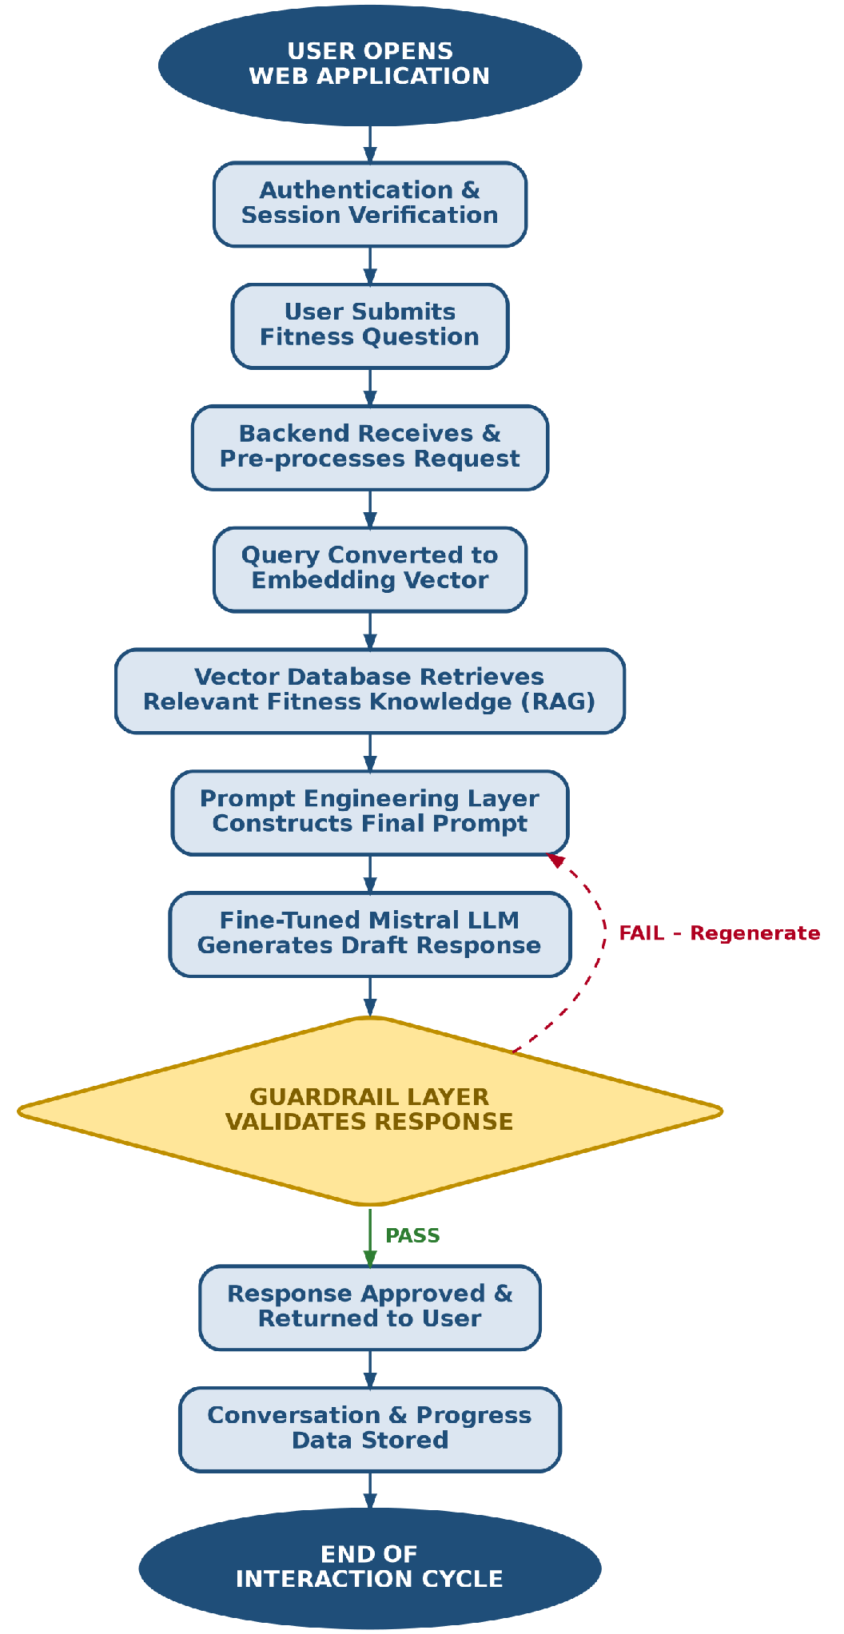
Figure 3.2: Logical flow of a fitness query through the proposed system, including the guardrail rejection/regeneration loop.
1. User Opens Web Application. The user launches the React-based client in a browser. This is the natural starting point because no other stage can occur without an active client session.
2. Authentication and Session Verification. The backend confirms the user's identity via the authentication service. This gate exists because every downstream stage depends on knowing which user's profile and memory to load.
3. User Submits Fitness Question. Free-text input is sent to the FastAPI backend. Free text, rather than fixed menu options, is what allows the system to be an open conversational agent rather than a scripted tool.
4. Backend Receives and Pre-processes Request. The request is validated and normalized (trimming, encoding checks) before further processing. Pre-processing here prevents malformed input from propagating errors into the Artificial Intelligence (AI) layer.
5. Query Converted to Embedding Vector. The embedding model transforms the query into a numeric vector. This step is required because the vector database cannot compare raw text against its indexed documents directly.
6. Vector Database Retrieves Relevant Fitness Knowledge (Retrieval-Augmented Generation). The most semantically similar knowledge-base passages are fetched. This is the point at which factual grounding enters the pipeline, directly reducing reliance on the model's memorized knowledge.
7. Prompt Engineering Layer Constructs the Final Prompt. Retrieved passages, the user's profile, and conversation memory are merged into a single structured prompt. This is where personalization and context awareness are operationalized before generation even begins.
8. Fine-Tuned Mistral-Based Large Language Model Generates a Draft Response. The specialized model, served via the Hugging Face Inference API, produces candidate text. Because the model has been fine-tuned with QLoRA on fitness data, this draft is already biased toward fitness-appropriate vocabulary and structure.
9. Guardrail Layer Validates the Response. Rule-based and classifier checks scan the draft for unsafe medical claims, off-domain content, or contraindicated advice. If validation fails, the request loops back to the prompt construction stage for regeneration, shown by the dashed feedback path in Figure 3.2 — this loop is the direct mechanism through which the system is guarded, not merely trained.
10. Response Approved and Returned to User. Once validated, the response is formatted and delivered to the web client.
11. Conversation and Progress Data Stored. The exchange is logged to chat history, conversation memory is updated, and any relevant progress metrics are recorded. This closes the loop that makes future interactions context-aware.
12. End of Interaction Cycle. The system returns to an idle, ready state awaiting the next query.

3.5.3 Use Case Diagram of the Proposed System
The use-case diagram identifies every actor that interacts with the system and the specific behaviours (use cases) each actor triggers, together with the include/extend relationships that show how internal use cases depend on one another.
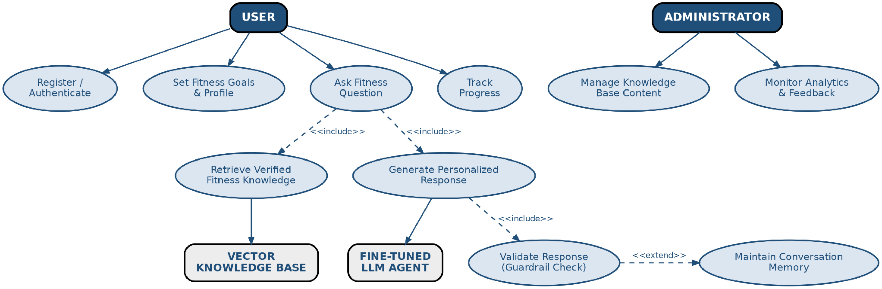
Figure 3.3: Use case diagram showing human and system actors and their interactions with the fitness chatbot system.
User — the primary human actor who registers, sets goals, asks fitness questions, and tracks progress. The entire system exists to serve this actor's fitness journey, which is consistent with the project's stated aim.
Administrator — manages knowledge-base content and monitors analytics and guardrail activity, since a fine-tuned model and a curated knowledge base both require ongoing human oversight, which this actor provides.
Fine-Tuned LLM Agent — a system actor representing the Large Language Model (LLM) itself, since it actively generates and reasons rather than merely returning stored records; modelling it as an actor reflects the project's framing of the chatbot as an agent, not a static lookup tool.
Vector Knowledge Base — a system actor supplying retrieved context; representing it separately from the Large Language Model (LLM) actor makes explicit that retrieval and generation are distinct responsibilities.
Key Use Cases:
- Register / Authenticate — establishes a verified identity before any personalized behaviour can occur.
- Set Fitness Goals & Profile — supplies the structured attributes that personalization depends on.
- Ask Fitness Question — the core interaction that triggers the retrieval-generation-guardrail pipeline.
- Retrieve Verified Fitness Knowledge — an included use case invoked automatically whenever a question is asked, grounding the answer in real documents.
- Generate Personalized Response — an included use case that produces the draft answer using the retrieved context and user profile.
- Validate Response (Guardrail Check) — an included use case that must pass before any response reaches the user, and which may extend into a regeneration cycle.
- Maintain Conversation Memory — extends the response cycle by persisting context for future turns.
- Track Progress — lets the user log outcomes that feed back into future personalization.
- Manage Knowledge Base Content / Monitor Analytics & Feedback — administrator-side use cases that keep the system accurate and safe over time.

3.5.4 Database Structure of the Proposed System
The database is designed conceptually around one central entity — the user — with satellite entities capturing goals, activity, nutrition, conversation, and knowledge.
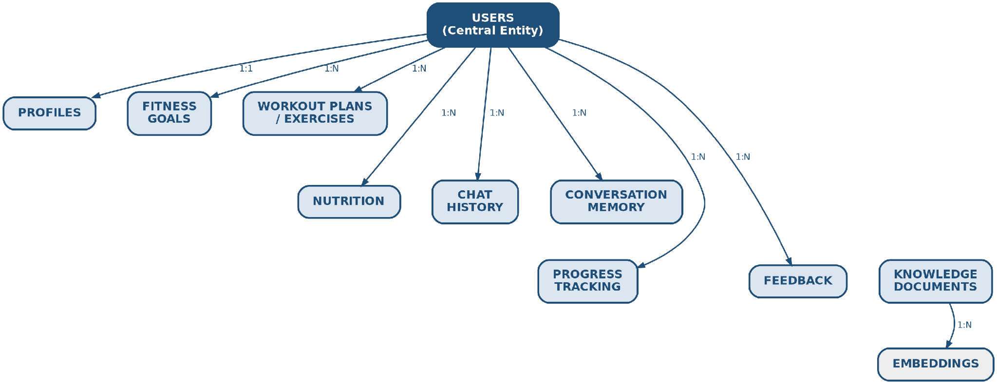
Figure 3.4: Simplified conceptual database structure showing entities and their primary relationships.
Users: Stores login credentials and identity records. Every personalized recommendation, memory record, and safety decision must be traceable to a single authenticated user.
Profiles: Stores age, gender, weight, height, fitness level, medical flags. The fine-tuned model needs structured user attributes as prompt context so the same question yields a response fitted to the individual.
Fitness Goals: Stores goal type (weight loss, muscle gain, cardiovascular improvement) and target values. Goal tracking is one of the four stated objectives of this research.
Workout Plans / Exercises: Stores generated or assigned routines and their constituent exercises, separated so plans can be regenerated or adjusted without losing history.
Nutrition: Stores meal entries and macronutrient breakdowns, letting the agent reason over dietary history.
Chat History: Stores every user–agent exchange with timestamps, forming the audit trail required for guardrail accountability.
Conversation Memory: Stores a compressed running summary of the dialogue, keeping the Large Language Model's (LLM's) context window efficient while preserving continuity across sessions.
Progress Tracking: Stores periodic measurements (weight, endurance test results, etc.), converting qualitative encouragement into quantitative evidence.
Knowledge Documents / Embeddings: Stores verified fitness reference material and its vector representations — the backbone of the Retrieval-Augmented Generation (RAG) layer.
Feedback: Stores user ratings and corrections on chatbot responses, closing the improvement loop described in Chapter Five's recommendations.
The relationships are predominantly one-to-many from the Users entity outward (one user has many goals, many chat messages, many progress records), and separately from the Knowledge Documents entity outward (one document has one or more embeddings).

3.5.5 Architecture of the Proposed System
This section presents the layered software architecture that realises everything described in the preceding sections.
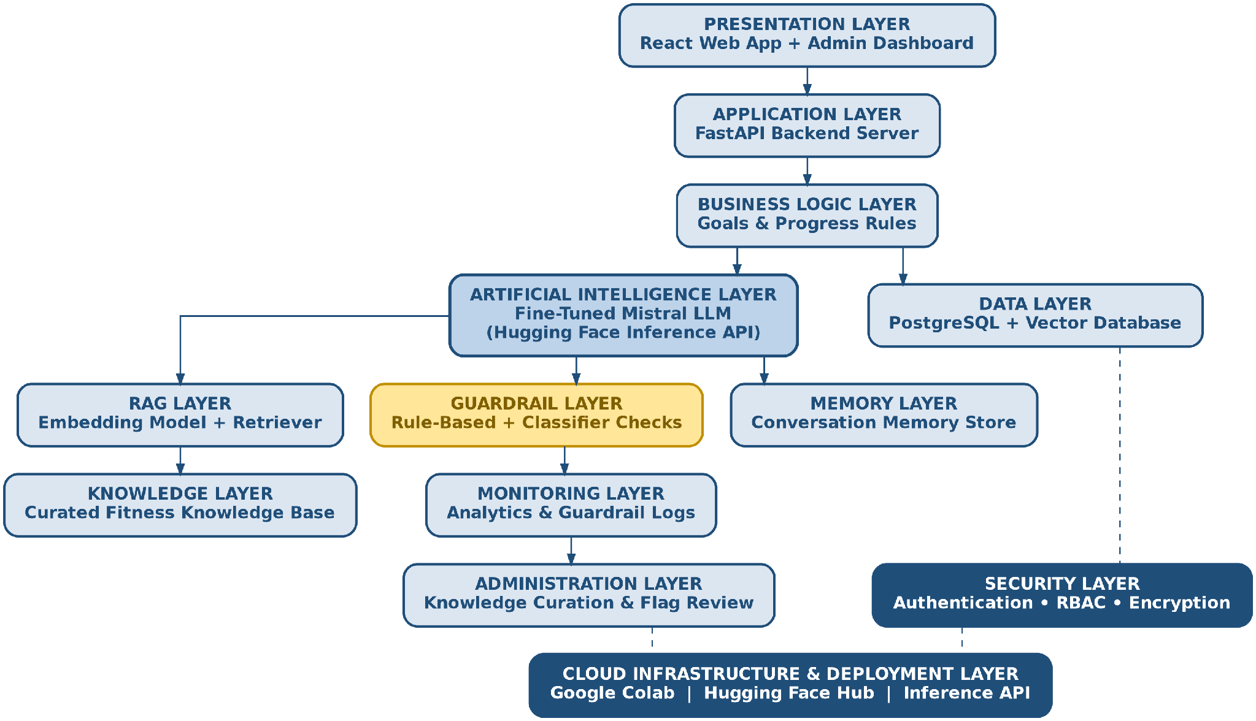
Figure 3.1: Layered architecture of the proposed fitness chatbot system, from the presentation layer down to monitoring and administration.
Presentation Layer — Renders the React web application and admin dashboard interfaces, drawing on user clicks and text entry as its input and producing rendered screens and outgoing API requests as its output. Separates what the user sees from how requests are processed.
Application Layer — The FastAPI backend server that authenticates requests and routes them to the correct internal service, drawing on authenticated API calls as its input and producing routed internal requests as its output.
Business Logic Layer — Enforces application rules such as goal-setting constraints and progress-calculation formulas, keeping domain rules out of both the interface code and the Artificial Intelligence (AI) code.
Artificial Intelligence (AI) Layer — Houses the prompt engineering module and the QLoRA fine-tuned Mistral-based Large Language Model (LLM), served through the Hugging Face Inference API, drawing on assembled prompts as its input and producing draft natural-language responses as its output.
Retrieval-Augmented Generation (RAG) Layer — Coordinates the embedding model, vector database, and retriever to supply grounding context, drawing on the user's query as its input and producing ranked relevant passages as its output.
Knowledge Layer — Stores and manages the curated fitness knowledge base independently of the model's fine-tuning data.
Guardrail Layer — Validates every draft response for safety and domain relevance before release, producing an approved response or a rejection signal that triggers regeneration.
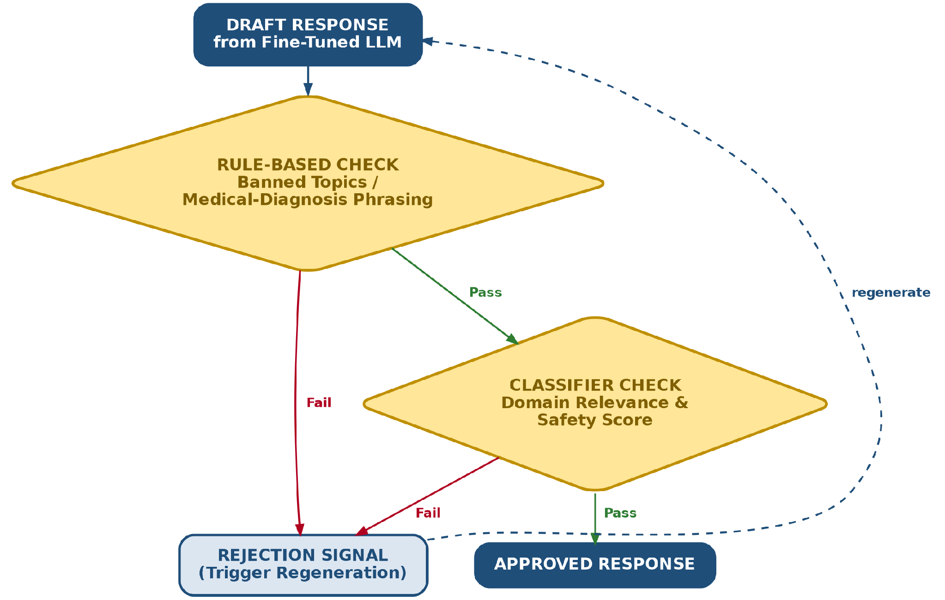
Figure 3.6: Guardrail decision flow showing the domain-relevance and safety checks a draft response must pass before release, and the regeneration path triggered on failure.
Memory Layer — Persists compressed conversation state across sessions, producing a running context summary available to the prompt engineering module.
Data Layer — The relational database (PostgreSQL) storing users, profiles, goals, plans, and progress.
Monitoring Layer — Logs system performance, guardrail rejection rates, and usage analytics, producing dashboards and alerts.
Administration Layer — Gives administrators controlled access to knowledge-base curation and flagged-content review.
Security Layer — Enforces authentication, role-based access, and encryption across all other layers.
Cloud Infrastructure and Deployment Layer — Hosts all preceding layers on Google Colab (training), the Hugging Face Hub (artifact storage), and the Hugging Face Inference API (serving), consistent with the cloud-only hardware profile defined in Section 3.5.1.1.
Taken together, this architecture is more scalable than the traditional, monolithic chatbot architectures reviewed in Section 3.1 because each concern — presentation, business logic, retrieval, generation, safety, memory, and data — is isolated behind a defined interface. In the proposed system, the fine-tuned Mistral-based model can be retrained, the knowledge base refreshed, or the guardrail rules tightened, each independently of the others, which is the practical meaning of scalability and maintainability claimed in Section 3.4.

REFERENCES
Aggarwal, A., Tam, C. C., Wu, D., Li, X., & Qiao, S. (2023). Artificial intelligence-based chatbots for promoting health behavioral changes: Systematic review. Journal of Medical Internet Research, 25, e40789.
An, B., Zhang, S., & Dredze, M. (2025). RAG LLMs are not safer: A safety analysis of retrieval-augmented generation for large language models. arXiv preprint arXiv:2504.18041.
Bora, A., & Cuayáhuitl, H. (2024). Systematic analysis of retrieval-augmented generation-based LLMs for medical chatbot applications. Machine Learning and Knowledge Extraction, 6(4), 2355–2374.
Dergaa, I., Ben Saad, H., El Omri, A., Glenn, J. M., Clark, C. C. T., & Washif, J. A. (2024). Using artificial intelligence for exercise prescription in personalised health promotion: A critical evaluation of OpenAI's GPT-4 model. Biology of Sport, 41(2), 221–241.
Dettmers, T., Pagnoni, A., Holtzman, A., & Zettlemoyer, L. (2023). QLoRA: Efficient finetuning of quantized LLMs. Advances in Neural Information Processing Systems, 36. arXiv:2305.14314.
Düking, P., Sperlich, B., Voigt, L., Van Hooren, B., Zanini, M., & Zinner, C. (2024). ChatGPT generated training plans for runners are not rated optimal by coaching experts, but increase in quality with additional input information. Journal of Sports Science and Medicine, 23, 56–65.
Gao, Y., Xiong, Y., Gao, X., Jia, K., Pan, J., Bi, Y., Dai, Y., Sun, J., Wang, M., & Wang, H. (2024). Retrieval-augmented generation for large language models: A survey. arXiv preprint arXiv:2312.10997.
Ghosh, S., Varshney, P., Sreedhar, M. N., Padmakumar, A., Rebedea, T., Varghese, J. R., & Parisien, C. (2025). AEGIS2.0: A diverse AI safety dataset and risks taxonomy for alignment of LLM guardrails. Proceedings of NAACL 2025, Vol. 1, 5992–6026.
Hu, E. J., Shen, Y., Wallis, P., Allen-Zhu, Z., Li, Y., Wang, S., Wang, L., & Chen, W. (2021). LoRA: Low-rank adaptation of large language models. arXiv preprint arXiv:2106.09685.
Inan, H., Upasani, K., Chi, J., Rungta, R., Iyer, K., Mao, Y., Tontchev, M., Hu, Q., Fuller, B., Testuggine, D., & Khabsa, M. (2023). Llama Guard: LLM-based input-output safeguard for human-AI conversations. arXiv preprint arXiv:2312.06674.
Jiang, A. Q., Sablayrolles, A., Mensch, A., Bamford, C., Chaplot, D. S., de las Casas, D., Bressand, F., Lengyel, G., Lample, G., Saulnier, L., Lavaud, L. R., Lachaux, M.-A., Stock, P., Le Scao, T., Lavril, T., Wang, T., Lacroix, T., & El Sayed, W. (2023). Mistral 7B. arXiv preprint arXiv:2310.06825.
Ke, Y. H., Jin, L., Elangovan, K., et al. (2025). Retrieval augmented generation for 10 large language models and its generalizability in assessing medical fitness. npj Digital Medicine, 8, 187.
Lai, X., Lai, Y., Chen, J., Huang, S., Gao, Q., & Huang, C. (2025). Evaluation strategies for large language model-based models in exercise and health coaching: Scoping review. Journal of Medical Internet Research, 27, e79217.
Lee, K. (2026). Consistency of AI-generated exercise prescriptions: A repeated generation study using a large language model. arXiv preprint arXiv:2604.11287.
Mangrulkar, S., Gugger, S., Debut, L., Belkada, Y., Paul, S., & Bossan, B. (2022). PEFT: State-of-the-art parameter-efficient fine-tuning methods. Hugging Face. https://github.com/huggingface/peft
Neha, F., Bhati, D., & Shukla, D. K. (2025). Retrieval-augmented generation (RAG) in healthcare: A comprehensive review. AI, 6(9), 226.
Ong, Q. C., Ang, C. S., Chee, D. Z. Y., et al. (2024). Advancing health coaching: A comparative study of large language model and health coaches. Artificial Intelligence in Medicine, 157, 103004.
Rebedea, T., Dinu, R., Sreedhar, M., Parisien, C., & Cohen, J. (2023). NeMo Guardrails: A toolkit for controllable and safe LLM applications with programmable rails. Proceedings of the 2023 Conference on Empirical Methods in Natural Language Processing (System Demonstrations).
Shin, D., Hsieh, G., & Kim, Y. H. (2023). PlanFitting: Tailoring personalized exercise plans with large language models. arXiv preprint arXiv:2309.12555.
Touvron, H., Martin, L., Stone, K., Albert, P., Almahairi, A., Babaei, Y., Bashlykov, N., Batra, S., Bhargava, P., Bhosale, S., et al. (2023). Llama 2: Open foundation and fine-tuned chat models. arXiv preprint arXiv:2307.09288.
Washif, J. A., Pagaduan, J., James, C., Dergaa, I., & Beaven, C. (2024). Artificial intelligence in sport: Exploring the potential of using ChatGPT in resistance training prescription. Biology of Sport, 41, 209–220.
Historical-Origin Citations
The following two works predate this project's 2022–2026 citation window but are retained because they originate the foundational concepts — the Transformer architecture and Retrieval-Augmented Generation — that every other reference above builds on.
Vaswani, A., Shazeer, N., Parmar, N., Uszkoreit, J., Jones, L., Gomez, A. N., Kaiser, Ł., & Polosukhin, I. (2017). Attention is all you need. Advances in Neural Information Processing Systems, 30.
Lewis, P., Perez, E., Piktus, A., Petroni, F., Karpukhin, V., Goyal, N., Küttler, H., Lewis, M., Yih, W., Rocktäschel, T., Riedel, S., & Kiela, D. (2020). Retrieval-augmented generation for knowledge-intensive NLP tasks. Advances in Neural Information Processing Systems, 33, 9459–9474.

